Power BI – Module End Evaluation Documentation

Q1 – Data Cleaning and Loading

Step 1: Import the CSV
Power BI Desktop → Home → Get Data → Text/CSV → select SalesData_1000Rows_WithIssues_copy.csv → Transform Data. This opens Power Query Editor.

Step 2: Set data types
Set OrderID and Quantity to Whole Number; OrderDate to Date; UnitPrice, Sales, Cost and Profit to Decimal Number; and CustomerName, Region, Product and Category to Text.
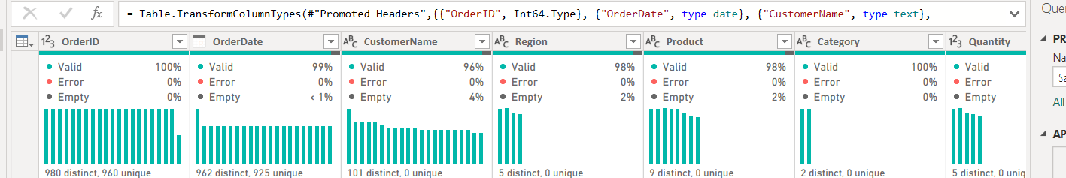

Step 3: Remove duplicate orders
Because OrderID identifies an order, remove duplicate OrderIDs rather than only exact duplicate rows. Sort each repeated OrderID by data completeness and retain the most complete record. This resolves the 20 repeated OrderID occurrences. For example, OrderID 1741 has one record with a missing date and one complete date; the complete record is retained. OrderID 1762 has one record with missing Profit and one complete Profit value; the complete record is retained.

Step 4: Handle missing categorical values
Replace blank CustomerName, Region and Product values with 'Unknown'. This preserves the order instead of deleting it and makes the missing-data condition visible in reports.
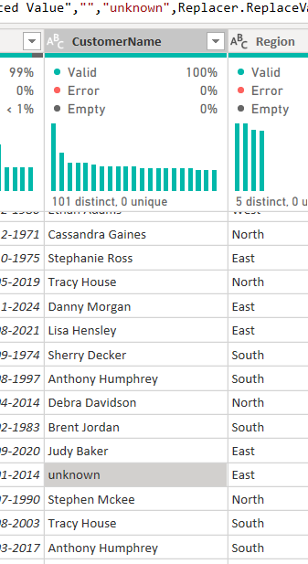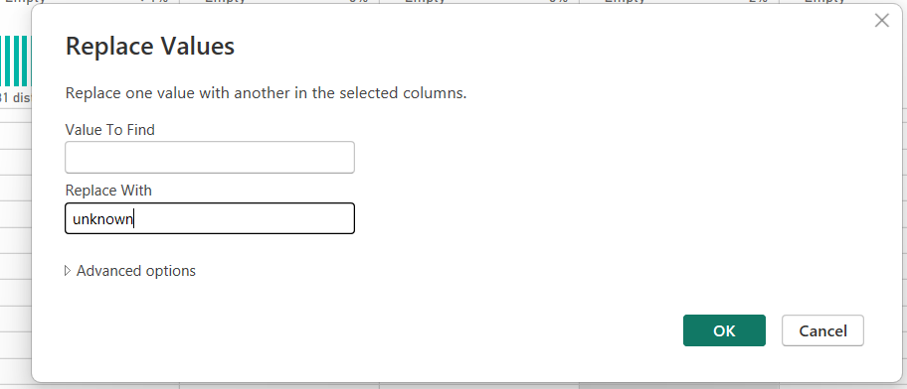

Step 5: Recover missing numeric values
The supplied data follows these relationships: Sales = Quantity × UnitPrice and Profit = Sales − Cost. Therefore, missing UnitPrice can be recovered as Sales ÷ Quantity; missing Sales as Quantity × UnitPrice; missing Cost as Sales − Profit; and missing Profit as Sales − Cost. These formulas are preferable to arbitrary averages because they preserve the dataset's own arithmetic relationships.
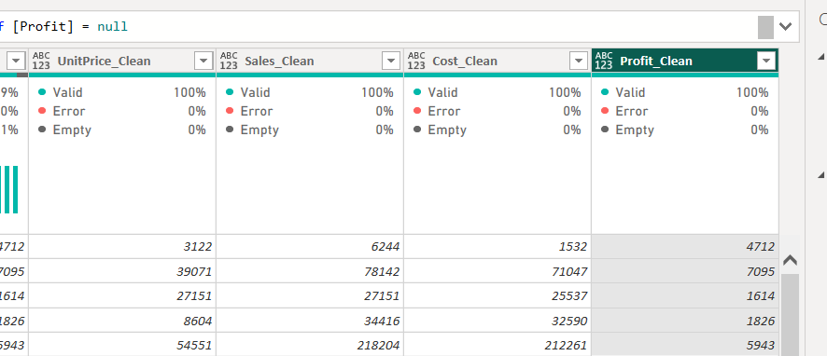

Step 6: Standardize OrderDate
Use Power Query Transform → Data Type → Date, with the source interpreted as day-month-year where required. The final stored format is YYYY-MM-DD. One OrderDate could not be recovered from the supplied data, so that single record was removed because an unknown date cannot support a valid time-trend analysis.

Step 7: Load the cleaned table
Click Home → Close & Apply. The resulting analysis table contains 999 rows. Verify that the fields have the intended data types and that no required numeric or categorical field remains blank.

Q2 – Visualizations and Insights

A. Pie Chart – Order Distribution by Region
Insert → Pie Chart. Place Region in Legend and OrderID in Values, then set OrderID aggregation to Count (or use a Count of rows). Turn on data labels and percentage labels. If the assessment wants only known geographic regions, filter Region ≠ Unknown; otherwise keep Unknown visible as a data-quality category.
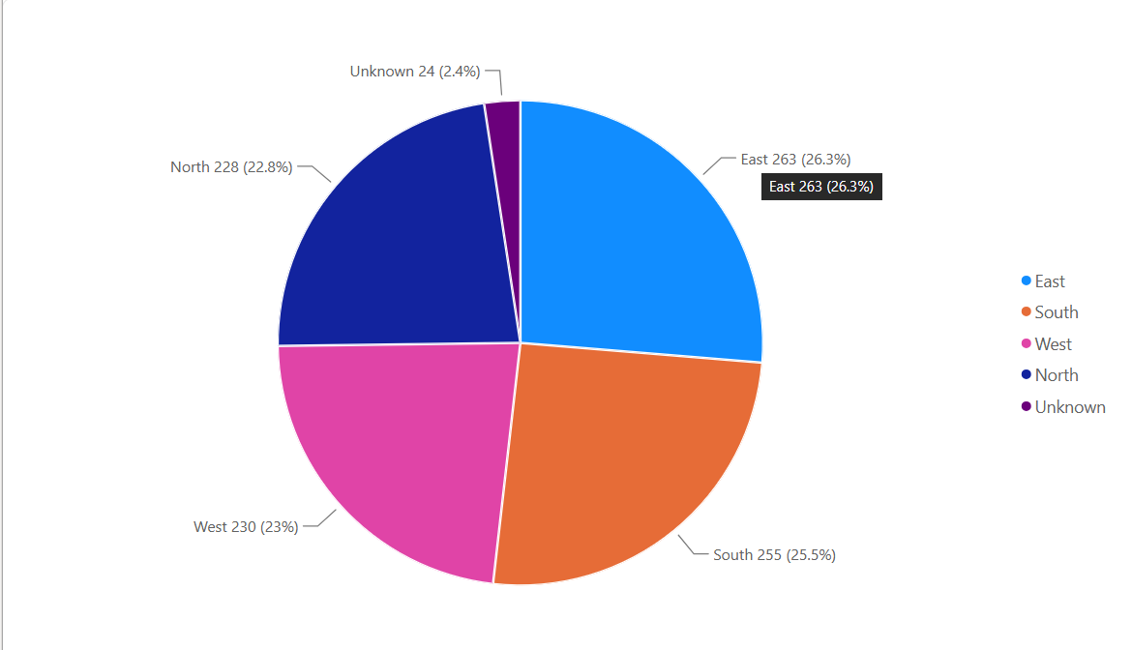

B. Column Chart – Top 5 Products
Insert → Clustered Column Chart. Put Product on X-axis and OrderID on Y-axis with Count. In Filters on this visual, choose Product → Top N → Top 5 → By value: Count of OrderID. Sort descending by order count.
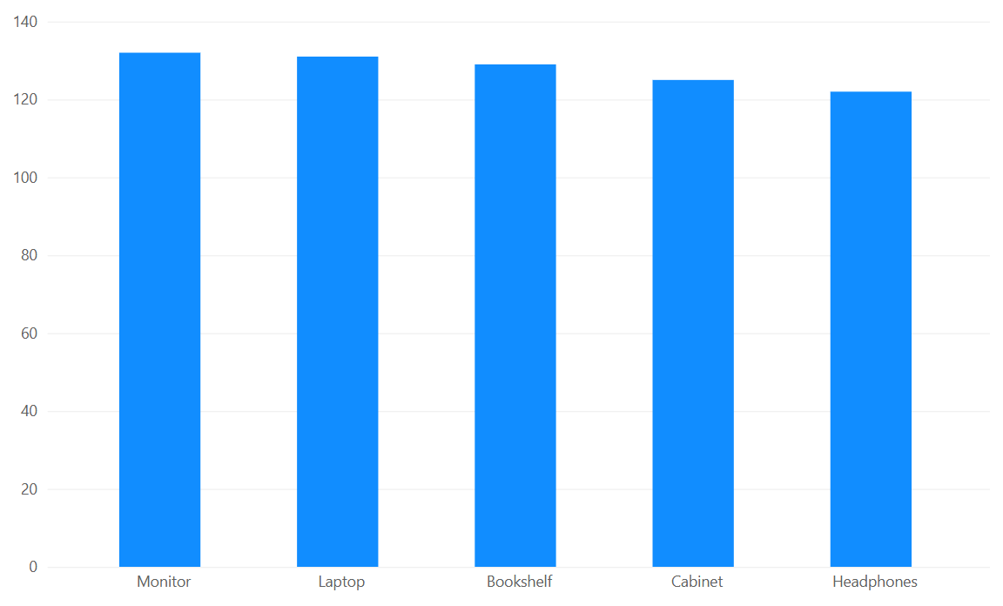

C. Line Chart – Profit Trend Over Time
Insert → Line Chart. Put OrderDate on the X-axis and Profit on the Y-axis. Use the Date hierarchy or create a Month/Year field if a monthly trend is required. Use Sum of Profit. Sort dates ascending. Add a descriptive title such as 'Monthly Profit Trend'.
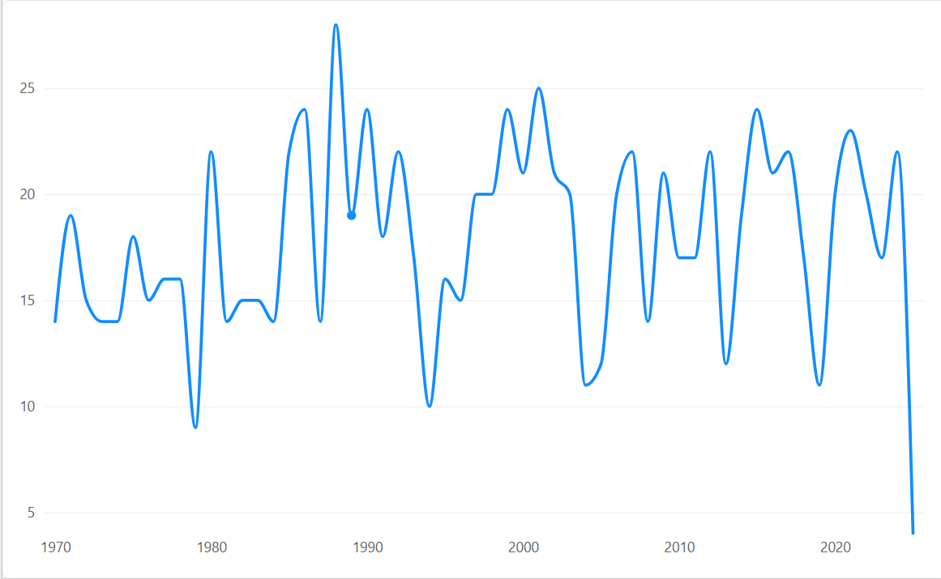

Q3 – DAX Calculations

A. Calculated Table – EastRegionOrders
Go to Modeling → New Table and enter:
EastRegionOrders = FILTER('SalesData', 'SalesData'[Region] = "East")

Replace 'SalesData' with the exact name of your cleaned table if Power BI gives it a different name. The calculated table contains only rows whose Region is East.
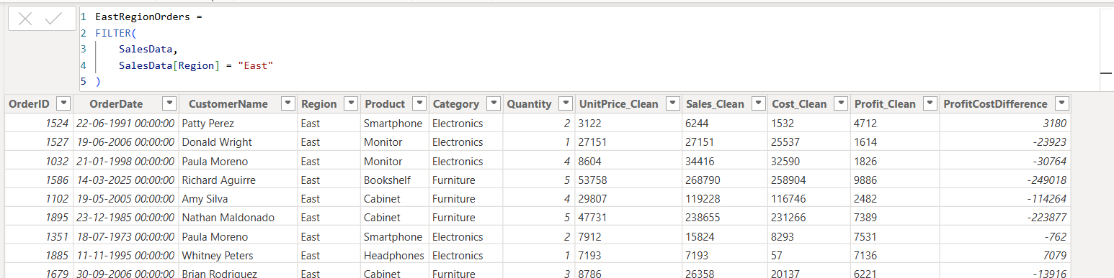

B. Calculated Column – ProfitCostDifference
Modeling → New Column:
ProfitCostDifference = 'SalesData'[Profit] - 'SalesData'[Cost]
This performs a row-by-row subtraction of Cost from Profit.
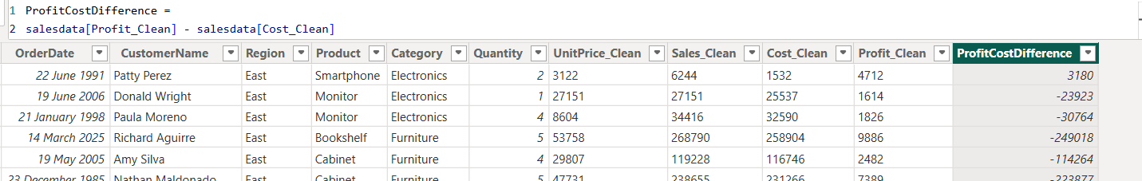

C. Measure – TotalProfit
Modeling → New Measure:
TotalProfit = SUM('SalesData'[Profit])
For the cleaned file prepared from the supplied data, TotalProfit is 5,137,115
